Multiple-choice section

|  |  |  |  |  |  |  |  |  |
| --- | --- | --- | --- | --- | --- | --- | --- | --- |
| Question | 1 | 2 | 3 | 4 | 5 | 6 | 7 | 8 |
| Answer | D | C | A | A | C | A | B | C |

Question 1 [9.1]

D

2 + 4 + 6 + 3 = 15

Black:  × 1000 ≈ 133

Orange:  × 1000 = 200

Question 2 [9.2]

C

The range is the difference between the highest and lowest score.

Question 3 [9.5]

A

Any possible result of an event is called an outcome.

Question 4 [9.6]

A

There are 13 hearts and 52 cards altogether in a standard pack of playing cards.

Probability of drawing a heart:

= 

Question 5 [9.7]

C

The Greek letter ξ (xi) is used to represent the universal set.

Question 6 [9.5]

A

There are 20 numbers altogether and 11 have the number 1 in them:  
1, 10, 11, 12, 13, 14, 15, 16, 17, 18, 19.

Probability of drawing a number with a 1 in it is .

Question 7 [9.4]

B

Class centre = 

Question 8 [9.4]

C

a histogram

Multiple-choice total marks: 8

Short answer section

Question 9 2 marks [9.7]

(a) A Venn diagram or a two-way table can be used to work out the *probability* of an outcome occurring from overlapping events

(b) The *intersection* of *A* and *B* includes the outcomes that are in both *A* and *B*.

Question 10 2 marks [9.1]

Random sampling is the name given to sampling where there is no pattern involved in the sampling process. Random sampling eliminates bias. Selecting names out of a hat is an example of   
random sampling.

Question 11 2 marks [9.1]

Example 1 is a convenience sample because the group are together so easy to see all at one time. It is also a judgement sample as people preparing lunches at schools are health conscious.

Bias is very likely as, even though the group’s opinions may be valid, it doesn’t mean they reflect opinions held generally in the community.

Question 12 3 marks [9.6]

(a) 1 – (0.12 + 0.26 + 0.31 + 0.17 + 0.08 + 0.02) = 0.04

|  |  |
| --- | --- |
| Children in the family | Probability |
| 0 | 0.12 |
| 1 | 0.26 |
| 2 | 0.31 |
| 3 | 0.17 |
| 4 | 0.08 |
| 5 | **0.04** |
| > 5 | 0.02 |

(b) (i) Pr(3 or 4) = 0.17 + 0.08 = 0.25   
0.25 × 850 = 212.5  
213 families

(ii) Pr(2+) = 0.31 + 0.17 + 0.08 + 0.04 + 0.02 = 0.62  
0.62 × 850 = 527  
527 families

Question 13 5 marks [9.4]

|  |  |  |
| --- | --- | --- |
| *x* | *f* | *x × f* |
| 11  12  13  14  15 | 1  0  3  12  4 | 11  0  39  168  60 |
| Total | 20 | 278 |

mean =  = 13.9

median is 10th/11th position: 14

mode: *f* = 12 ↔ *x* = 14

range = 15 – 11 = 4

Question 14 6 marks [9.3]

(a)

|  |  |
| --- | --- |
| Result | Frequency |
| 1–5  6–10  11–15  16–20  21–25 | 3  8  8  5  6 |

(b)

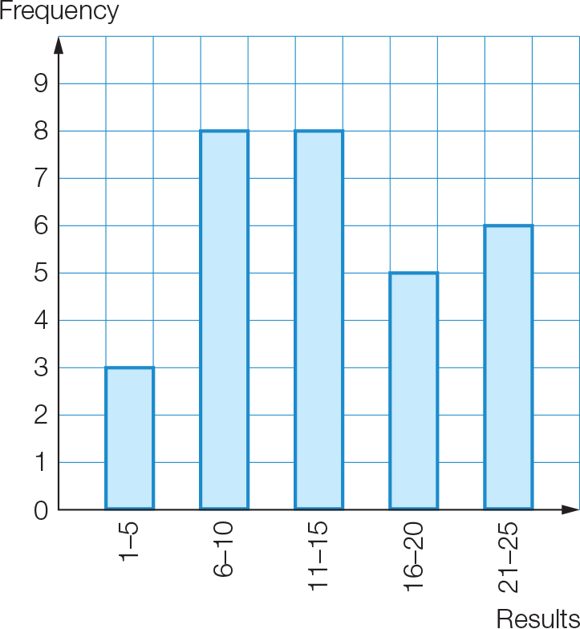

Question 15 2 marks [9.4]

(a) There are 16 pieces of data so the median is between the eighth and ninth values.  
median = (23 + 25) ÷ 2 = 24

(b)   
= 25.5625

Question 16 2 marks [9.5]

**(a)** Pr(not 7 or 9) =  = 

**(b)** Greater than 3, i.e. 4, 5, 6, 7, 8, 9, 10

Question 17 3 marks [9.6]

(a) Pr(A) =  (b) Pr(vowel) =  (c) Pr(M, A, T, E) = 

Question 18 4 marks [9.6]

(a) Pr(black or 4) =  =  = 

(b) Pr( black 4) =  = 

(c) Pr(black or 4 but not both) =  =  = 

Question 19 3 marks [9.7]

Total number of students = 2 + 25 + 12 + 16 = 55

(a) Total number of students who play the piano 12 + 25 = 37  
Pr(*P*) = 

(b) Pr(*P* or *G*) =  = 

(c) Pr(*P* and *G*) = 

Question 20 4 marks [9.7]

(a)

|  |  |  |  |
| --- | --- | --- | --- |
|  | Cat | No cat |  |
| Dog | 13 | 6 | 19 |
| No dog | 3 | 3 | 6 |
|  | 16 | 9 | 25 |

(b) Pr(cat and dog) = 

Short answer total marks: 38

Extended answer section

Question 21 8 marks [9.3, 9.4]

(a)

|  |  |  |  |
| --- | --- | --- | --- |
| Class interval | *x* | Frequency (*f*) | *xf* |
| 25–<30 | 27.5 | 8 | 220 |
| 30–<35 | 32.5 | 12 | 390 |
| 35–<40 | 37.5 | 14 | 525 |
| 40–<45 | 42.5 | 16 | 680 |
| 45–<50 | 47.5 | 15 | 712.5 |
| 50–<55 | 52.5 | 13 | 682.5 |
| 55–<60 | 57.5 | 12 | 690 |
|  |  | Σ*f* = 90 | Σ*xf* = 3900 |

(b) Horizontal axis: 25, 30, 35, 40, 45, 50, 55, 60

(c) (i) estimated mean =  =  = 43.3 (1 d.p)

(ii) modal class interval: *f* = 16 ↔ 40–<45

(iii) Both the 45th and 46th values are in the 40–<45 class interval, so  
median class interval is 40–<45.

Question 22 10 marks [9.1]

(a) (i) Set A: 6, 2, 10, 5, 2, 5, 4, 3, 3, 10. Mean =  = 5 letters per word  
Set B: 5, 6, 8, 9, 6, 2, 4, 4, 3, 2. Mean =  = 4.9 letters per word  
Set C: 6, 9, 9, 2, 3, 5, 3, 2, 5, 3. Mean =  = 4.7 letters per word  
Set D: 6, 5, 3, 11, 9, 2, 9, 6, 4, 2. Mean =  = 5.7 letters per word  
Set E: 3, 3, 4, 2, 7, 5, 4, 4, 9, 2. Mean =  = 4.3 letters per word  
Set F: 5, 1, 8, 9, 2, 4, 3, 2, 4, 3. Mean =  = 4.1 letters per word

(ii) Set A: Proportion of words with an ‘a’ =  = 0.3  
Set B: Proportion of words with an ‘a’=  = 0.2  
Set C: Proportion of words with an ‘a’=  = 0.2  
Set D: Proportion of words with an ‘a’=  = 0.2  
Set E: Proportion of words with an ‘a’=  = 0.4  
Set F: Proportion of words with an ‘a’=  = 0.4

(b) (i) Combined set A with B: Mean =  = 4.95 letters per word  
Combined set C with D: Mean =  = 5.2 letters per word  
Combined set E with F: Mean =  = 4.2 letters per word

(ii) Combined set A with B: Proportion of ‘a’ =  = 0.25  
Combined set C with D: Proportion of ‘a’=  = 0.2  
Combined set E with F: Proportion of ‘a’=  = 0.4

(c) Sample size 10:  
Range of means: 5.7 – 4.1 = 1.6 letters per word  
Range of proportion of words with an ‘a’: 0.4 – 0.2 = 0.2  
Sample size 20:  
Range of means: 5.2 – 4.2 = 1.0 letters per word  
Range of proportion of words with an ‘a’: 0.4 – 0.2 = 0.2  
Variation of means decreased with bigger sample size. There was no change in range of proportions but however the groups were paired the range could not have increased.

Extended answer total marks: 18

TOTAL test marks: 64